Sunday 13th June WORSHIP AT HOME 13th June
Welcome to our act of Worship

As we gather for worship, take a moment to reflect on these words:
‘Earth’s crammed with heaven, and every common bush afire with God.’ (Elizabeth Barrett Browning)

Call to worship Psalm 92v1-2
It is good to give thanks to the Lord,
to sing praises to your name, O Most High;
to declare your steadfast love in the morning,
and your faithfulness by night…

HYMN
Morning has broken like the first morning
Blackbird has spoken like the first bird
Praise for the singing, praise for the morning
Praise for them springing fresh from the world

Sweet the rains new fall, sunlit from Heaven
Like the first dewfall on the first grass
Praise for the sweetness of the wet garden
Sprung in completeness where His feet pass

Mine is the sunlight, mine is the morning
Born of the one light, Eden saw play
Praise with elation, praise every morning
God's recreation of the new day
HP635, MP467, RS45, STF136
(Some of the hymn books widely used in the Wiltshire United Area)

Prayer of Praise and Thanksgiving
God of grace and growth,
you have called us to plant the seeds of your kingdom
in the fields of your world,
and to trust you for their developing and flourishing –
and so we praise you.
For the abundance of your creativity:
we praise you.
For the transforming nature of your Spirit:
we praise you.
For the power of small beginnings:
we praise you.
For the mystery of hidden growth:
we praise you.
And for the harvest we are invited to delight in:
we praise you.
In Jesus’ name. Amen.

Prayer of Confession
God of all,
you do not force growth but nurture it.
Forgive us when we want too much too soon.
You do not start big but start small.
Forgive us when we want too much too soon.
You do not sow greedily but graciously.
Forgive us when we want too much too soon.
You do not hurry the harvest but hallow it.
Forgive us when we want too much too soon.
Forgive us, and accept the work of our hands,
in Jesus’ name. Amen.

HYMN
I sing the mighty power of God,
that made the mountains rise,
That spread the flowing seas abroad,
and built the lofty skies.
I sing the wisdom that ordained
the sun to rule the day;
The moon shines full at God's command,
and all the stars obey.
I sing the goodness of the Lord,
that filled the earth with food,
He formed the creatures through the Word,
and then pronounced them good.
Lord, how Thy wonders are displayed,
where'er I turn my eye,
If I survey the ground I tread,
or gaze upon the sky.

God’s hand is my perpetual guard,
He guides me with his eye.
Why should I then forget the Lord,
whose love is ever nigh?
HP334, MP, RS43, STF107

Ministry of the Word of God
Lectionary Bible readings for RCL Proper 6 Year B
Ezekiel 17.22-24; Psalm 92.1-4,12-15; 2 Corinthians 5.6-10(11-13)14-17;
Mark 4.26-34
26 He also said, ‘The kingdom of God is as if someone would scatter seed on the ground, ²⁷and would sleep and rise night and day, and the seed would sprout and grow, he does not know how. ²⁸The earth produces of itself, first the stalk, then the head, then the full grain in the head. ²⁹But when the grain is ripe, at once he goes in with his sickle, because the harvest has come.’
30 He also said, ‘With what can we compare the kingdom of God, or what parable will we use for it? ³¹It is like a mustard seed, which, when sown upon the ground, is the smallest of all the seeds on earth; ³²yet when it is sown it grows up and becomes the greatest of all shrubs, and puts forth large branches, so that the birds of the air can make nests in its shade.’
33 With many such parables he spoke the word to them, as they were able to hear it; ³⁴he did not speak to them except in parables, but he explained everything in private to his disciples.

This is the Gospel of Christ.
Praise to Christ our Lord.

Reflection
A picture is worth a 1000 words!

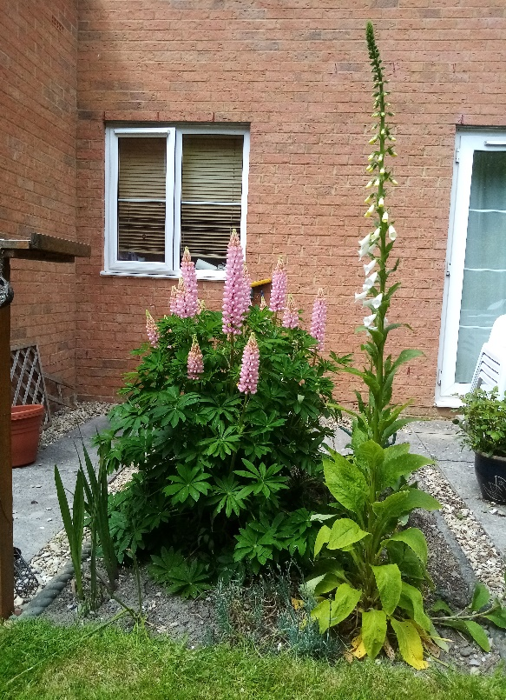

Three years ago, having begged and borrowed soil from neighbours skips I replaced most of an overly large patio to lawn and a border. Dominating the flower bed is a lupin which is literally festooned with stems of flowers and a foxglove which is taller than me. I still have the packet of seeds from which they were grown. From miniscule seed to mighty plants!

In today’s set Gospel Jesus speaks two parables both using seeds as illustrations to portray growth, patience and hope. Jesus shows how faith can grow from a small seed to a colossal plant with far-reaching branches, if the right environment is provided.

Many people find that the natural world can vividly speak of God’s presence, do you remember those words of Dorothy Gurney:
The kiss of the sun for pardon
The song of the birds for mirth
One is nearer to God’s heart in the garden
Than anywhere else on earth.

Whatever kind of gardener you are we all know that good growth does not just happen, it takes a great deal of work, not least a seemingly endless battle with weeds. And talking of those, in first century Palestine mustard, the theme of Jesus second parable, was considered a weed. So often when Jesus spoke about weeds it is in the negative, remember the parable of the sower and the seed that falls amongst the weeds and is choked. Or what about the one about the weeds and the wheat when the landowner imagines an enemy has sown weeds amongst his corn seed. It gets worse in Matthew 13 where Jesus even uses the burning of weeds as a symbol of judgement. So, what on earth is going on here where it appears a weed is praised?

Each manse garden I’ve had has had a different weed problem: Bristol groundsel, Blandford dandelions, Bournemouth Mares (Horses) Tail, North Devon Herb Bennet Westbury bindweed. One gardener on hearing of Mares Tail simply said “Move” when I asked how to eradicate it.

Weeds seem to persistently grow! And that is the link with Jesus’ parable of the mustard weed. Jesus uses the analogy to show how irrespective of people’s attitude to his kingdom, it will flourish. The Kingdom’s growth will be like a weed that takes over. You can refuse to plant it, you can try and pull it up or cut it down, but regardless, it will not go away and will always keep coming back.

The next time I am pulling up some of the everlasting bindweed it is going to be helpful to think of Jesus’ words in relation to the Kingdom. I am also going to think about them during those difficult occasions in church life where we can feel downbeat and at times defeated by the pressures and demands of simply seeking to be church in the here and the now.

Let Jesus’ message of these parables germinate within you, giving you hope, giving you strength, giving you peace. Let the message grow within you right where you are, so that you may know you are part of God’s Kingdom. The Kingdom that nothing can extinguish and which will grow for ever. Amen!

Prayer of Response:
Living God,
from a mustard seed to a tree, from I to we,
in you we grow. Amen.
In the mystery of the unseen, from brown field to green, in you we grow. Amen.
By faith and not by sight, by day and by night,
in you we grow. Amen.
Forgiven and freed, through word and deed,
in you we grow. Amen.
As we sow and reap, as we laugh and weep,
in you we grow. Amen.
May your kingdom come, Father, Spirit, Son,
as in you we grow. Amen.

HYMN
God is working his purpose out
as year succeeds to year:
God is working his purpose out,
and the time is drawing near;
nearer and nearer draws the time,
the time that shall surely be,
when the earth shall be filled
with the glory of God
as the waters cover the sea.

What can we do to work God's work,
to prosper and increase
the harmony of all the world,
the reign of the Prince of Peace?
What can we do to hasten the time,
the time that shall surely be,
when the earth shall be filled
with the glory of God
as the waters cover the sea.

March we forth in the strength of God,
with the banner of Christ unfurled,
that the light of the glorious gospel of truth
may shine throughout the world:
fight we the fight with sorrow and sin
to set their captives free,
that earth may filled
with the glory of God
as the waters cover the sea.

All we can do is nothing worth
unless God blessed the deed;
vainly we hope for the harvest-tide
till God gives life to the seed;
yet nearer and nearer draws the time,
the time that shall surely be,
when the earth shall be filled
with the glory of God
as the waters cover the sea.
HP769, MP189, RS573, STF

Our Prayers
God of the rich and the poor, of the powerful and the vulnerable,
we pray for the leaders of the G7 nations meeting in Cornwall,
for the people they govern,
for the people of other nations they can support,
and for the world they can protect through their decisions.
May wisdom be planted, generosity grow, and co-operation flourish.
We pray for a growth in resilience, awareness and togetherness
across all the nations of the world
as they continue to tackle the covid pandemic,
as they confront environmental issues.
and as they reach out to communities crippled by need, war and natural disasters.
May integrity be planted, urgency grow and healing flourish.
We pray for the church in this place and around the world
as we seek to serve those around us,
to reach out to those in trouble,
and to share the gospel, the good news of Jesus Christ.
May faith be planted, compassion grow and hope flourish.
We pray for those in the charity sector
who seek to support those in crisis,
to feed the hungry,
to embrace those displaced by war,
to protect wildlife and the environment, and planet that we all call home.
May trust be planted, resources grow and lives flourish.
And we pray for those whose faces we have seen on our screens
and in our papers this week.
for the family of Sarah Everard,
for little Artin and his family, and all those who have died crossing dangerous waters,
for Jimi Olubunmi-Adewole and his family and all who have died trying to save others,
for all who have enriched our world and for all who are at the mercy of others.
May justice be planted, goodness grow and peace flourish -
in Jesus name. Amen.

The Lord’s Prayer
Our Father, who art in heaven,
hallowed be thy name;
thy kingdom come;
thy will be done;
on earth as it is in heaven.
Give us this day our daily bread.
And forgive us our trespasses,
as we forgive those who trespass against us.
And lead us not into temptation;
but deliver us from evil.
For thine is the kingdom,
the power and the glory,
for ever and ever. Amen.

HYMN
All my hope on God is founded;
he doth still my trust renew,
me through change and chance he guideth,
only good and only true.
God unknown,
he alone
calls my heart to be his own.
Human pride and earthly glory,
sword and crown betray his trust;
what with care and toil we fashion buildeth,
tower and temple fall to dust.
But God's power,
hour by hour,
is my temple and my tower.
God's great goodness aye endureth,
deep his wisdom, passing thought:
splendour, light and life attend him,
beauty springeth out of naught.
Evermore
from his store
newborn worlds rise and adore.
Daily doth the almighty Giver
bounteous gifts on us bestow;
his desire our soul delighteth,
pleasure leads us where we go.
Love doth stand
at his hand;
joy doth wait on his command.
Still from earth to God eternal
sacrifice of praise be done,
high above all praises praising
for the gift of Christ, his Son.
Christ doth call
one and all:
ye who follow shall not fall.
HP63, MP16, RS586, STF455
Blessing
Go in peace to love and serve the Lord
In the name of Christ Amen.

Prayer for Little People
Living God,
open our eyes to the goodness of your creation. (look around)
Help us to care for it like a gardener (mime digging)
with times for planting, watering, harvesting and rest. (mime each one)
Help us to live in the rhythms of nature, (quietly tap a slow rhythm)
treading lightly (gentle ‘on the spot’ steps)
and hearing your voice call softly in the evening. (hand behind ear, listening).
Amen.

Through the Week
God of the small,
help me to do the little things that make a difference. Amen.

Rev David Coppard Superintendent @ Wiltshire United Area
Team Chaplain @ Musgrove Park Hospital, Taunton

Our churches may not all be open, but the Church is active and alive.

This is service is offered to any and all, with love and prayers.

CCL LICENCE
Steeple Ashton Methodist CCL 291605
Warminster United CCL 1221052
Westbury Methodist CCL 781988
Westbury URC CCL 293641

Since March 2020 Worship at Home has sought to provide a weekly link. With churches re-opening its ministry is completed and June 20th will see the last edition.

